Name: Juliette Joseph-Odogbo
Course: CIS-245-01A (Linux Administration)
Date: 09/19/2025

Virtual Machine Set Up
- Downloading Virtual Machine.
- Start by opening your web browser (such as Chrome, Microsoft Edge, or Firefox)
- In the address bar at the top, type: https://www.virtualbox.org and press Enter.
- On the VirtualBox homepage, click on the Downloads
- Next, choose the version for your operating system (for example, Windows hosts if you are on Windows)
- This will begin downloading the VirtualBox installer file

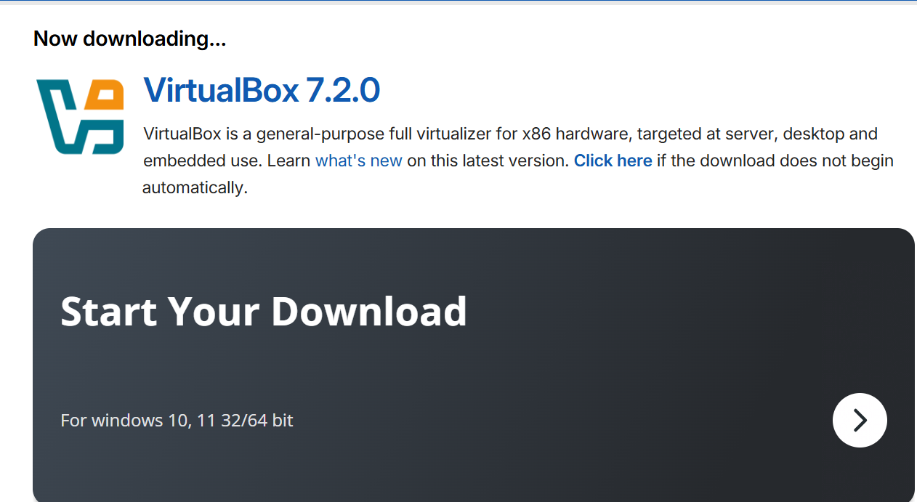

- Installing VirtualBox.
- Go to the Downloads Folder on your computer.
- Find the file you just downloaded (It will be called something like (VirtualBox -x.x.x.x Win (10))
- Double-click the file to start the installer
- A setup wizard will appear. Click next through the steps, leaving the default options selected.
- When asked for confirmation, click Yes to install
- When the installation is finished, click Finish
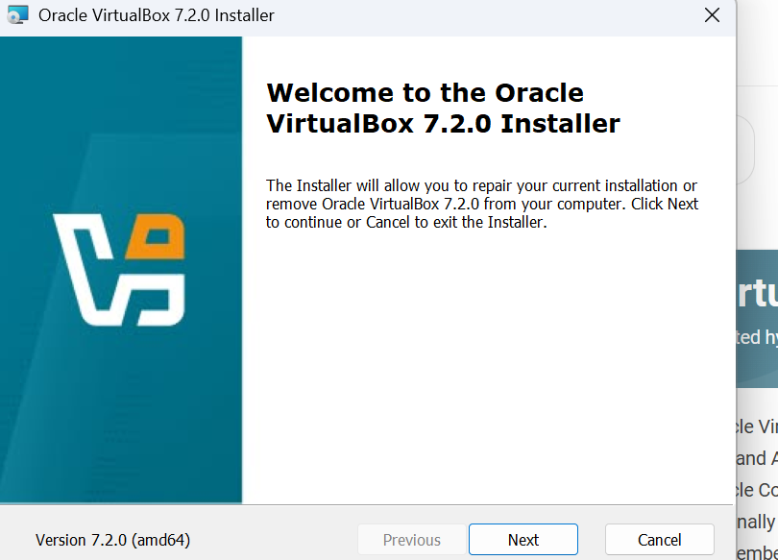
- Launching VirtualBox and Creating a New Virtual Machine.
- After installing, open the New Oracle VM VirtualBox Manager from your start menu.
- Click New to Start creating a virtual machine
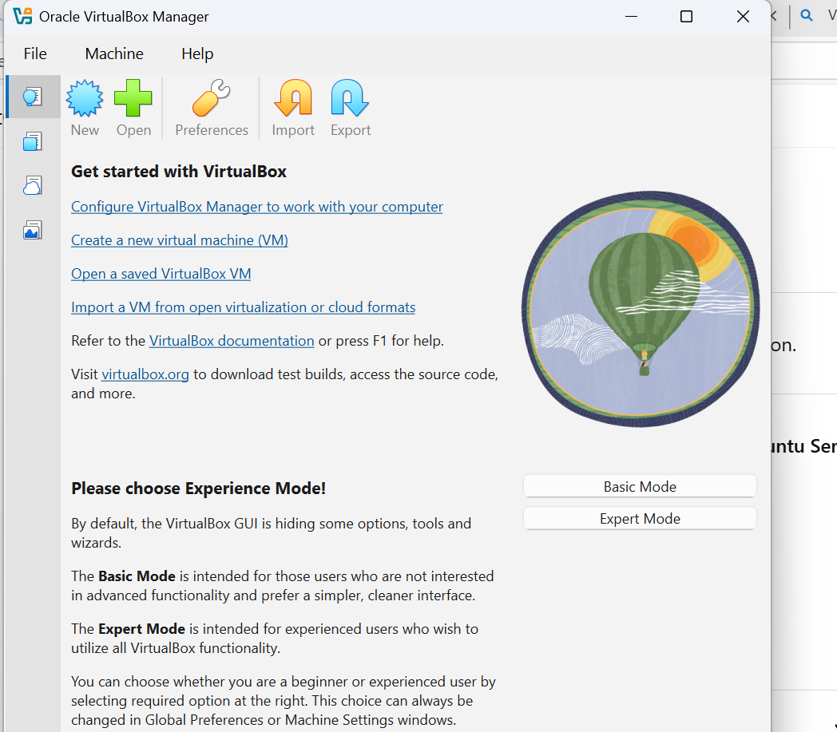
- Enter the name of the VM (for example., CentOS VM or Ubuntu Server).
- Select the downloaded ISO image file from your download Folder (these were obtained earlier from the official CentOS.org and Ubuntu.com websites)

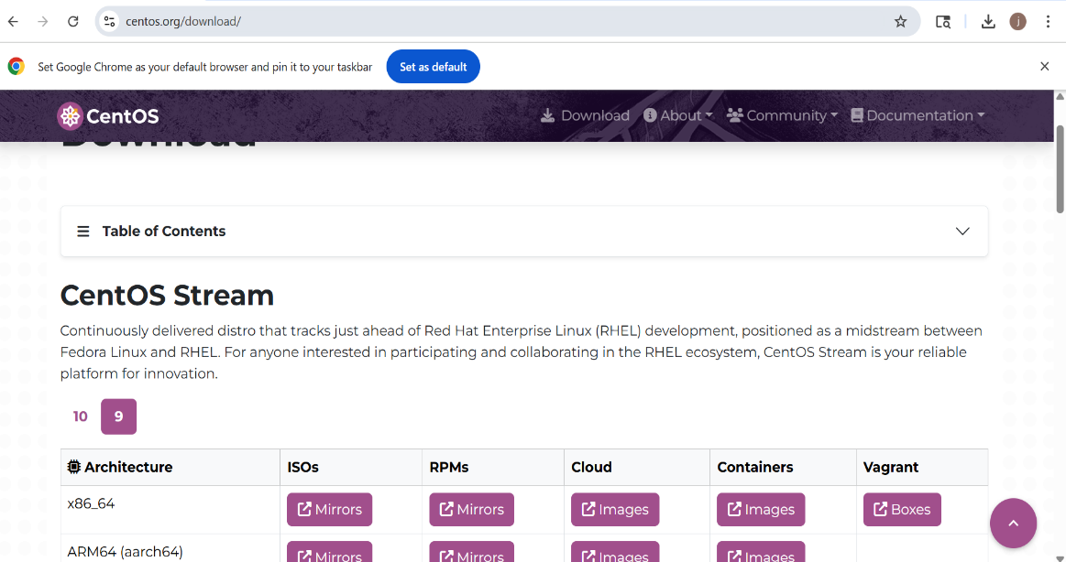

- Chose the operating system type as (Linux) and Version as Red Hat 64- bit)
- Click Next to continue.

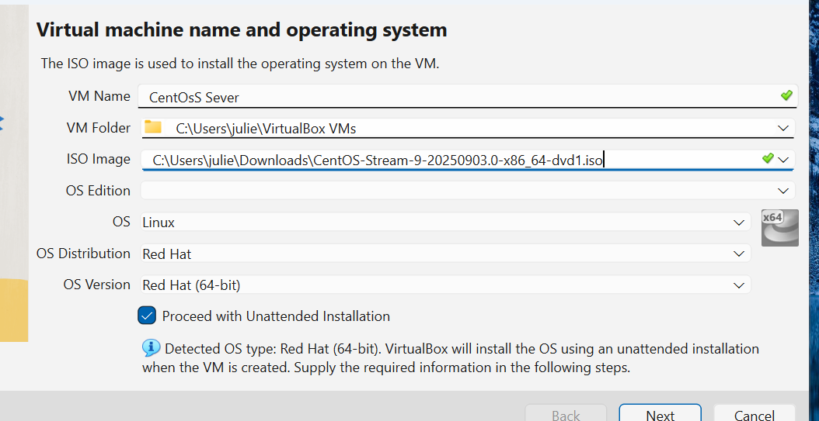

4. Configuring Virtual Machine Hardware.
- After creating the new VM. Adjust the virtual machine hardware resources,
- Chose the Base Memory (RAM) size. For example, set it to 4096 MB.
- Next, you will Select the number of CPUs (example: 2CPUs) needed for this virtual machine
- Next, Set the hard disk size (example: 20 GB)
- Next, Leave the EFI unchecked unless specially needed.
- Once the settings are correct, Click Next to continue

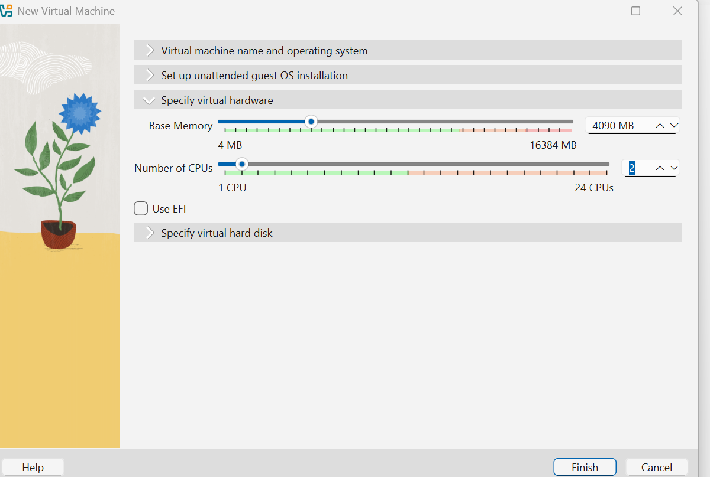

- Review the VM settings
- Check the summary screen.
- Make sure the Virtual Machine name, OS type, memory. CPU and hard disk are correct
- If everything looks good, click Finish
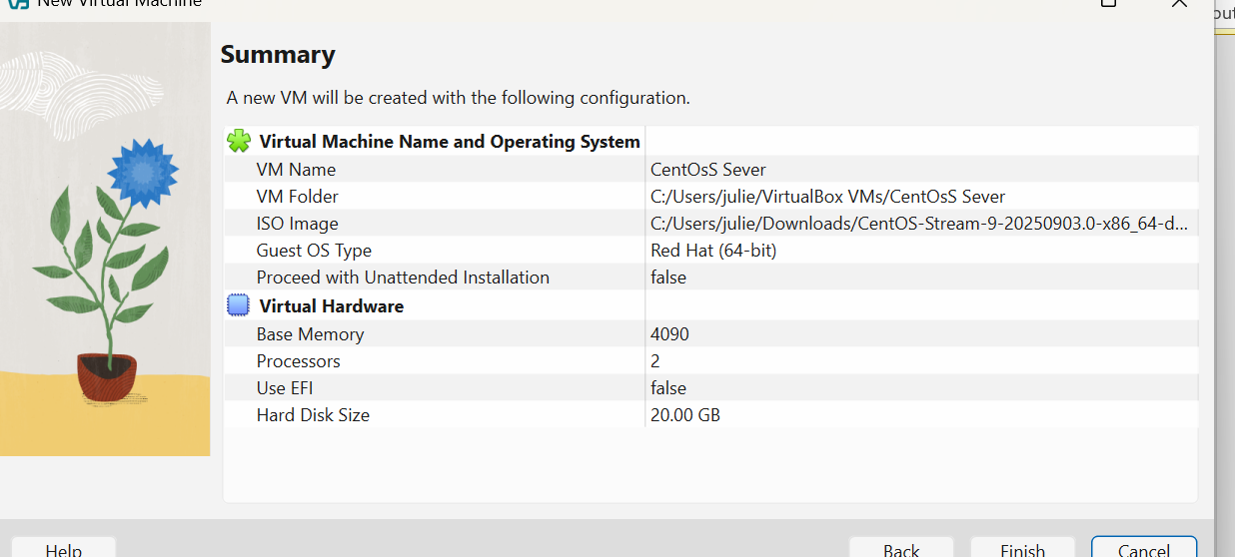
- Starting the CentOS Virtual Machine.
- In Oracle VirtualBox Manager, select the CentOS VM you just created.
- Click the start button (green arrow)
- The VM boot using the CentOS ISO file you attached earlier
- You should now see the CentOS installation menu on the screen
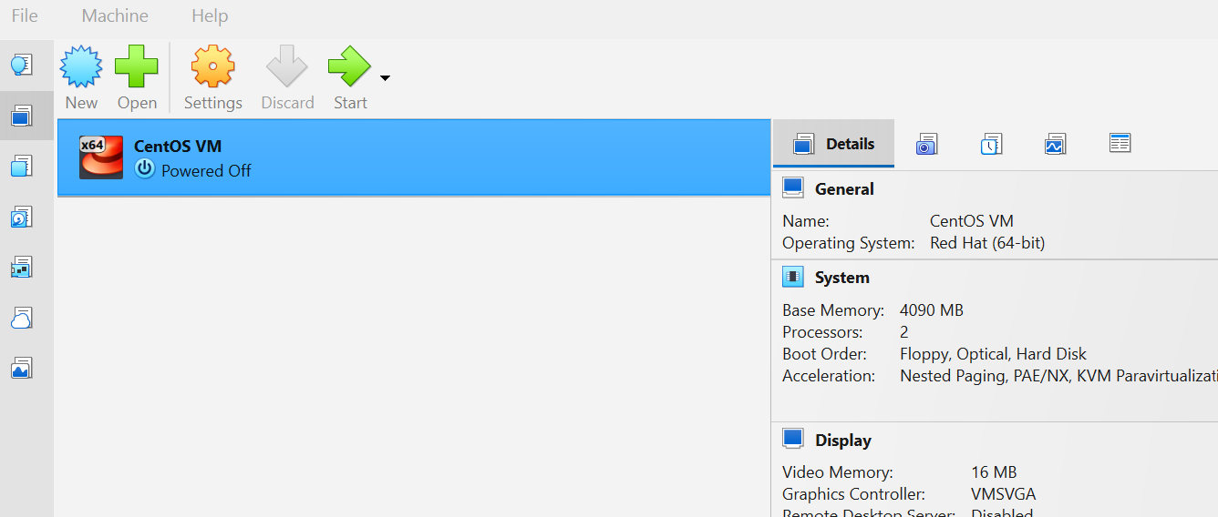

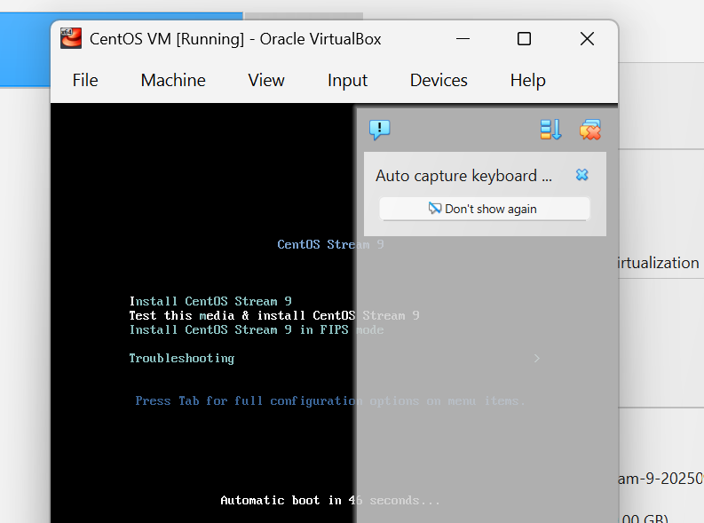

CentOS Installation.
- Choose Language and Keyboard
- On the first screen, select English (US for both)
- This ensures your server uses standard English settings
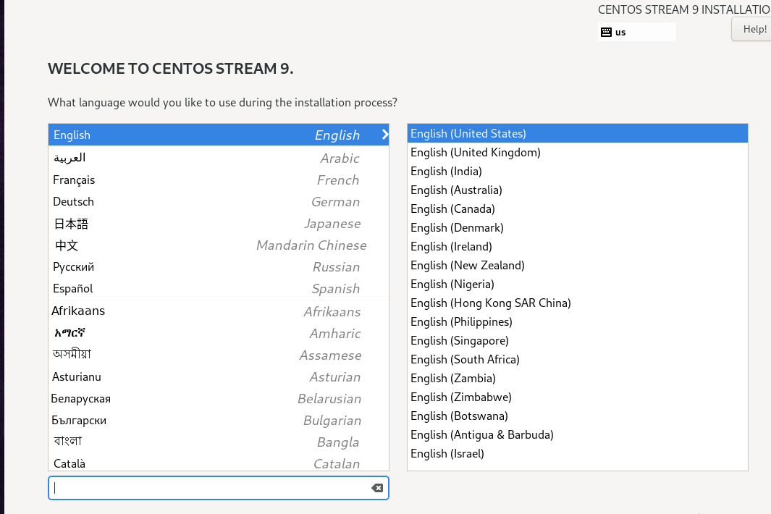

- Next, Set Time Zone
- Select your correct time (for example: New York)
- This keeps your sever clock accurate
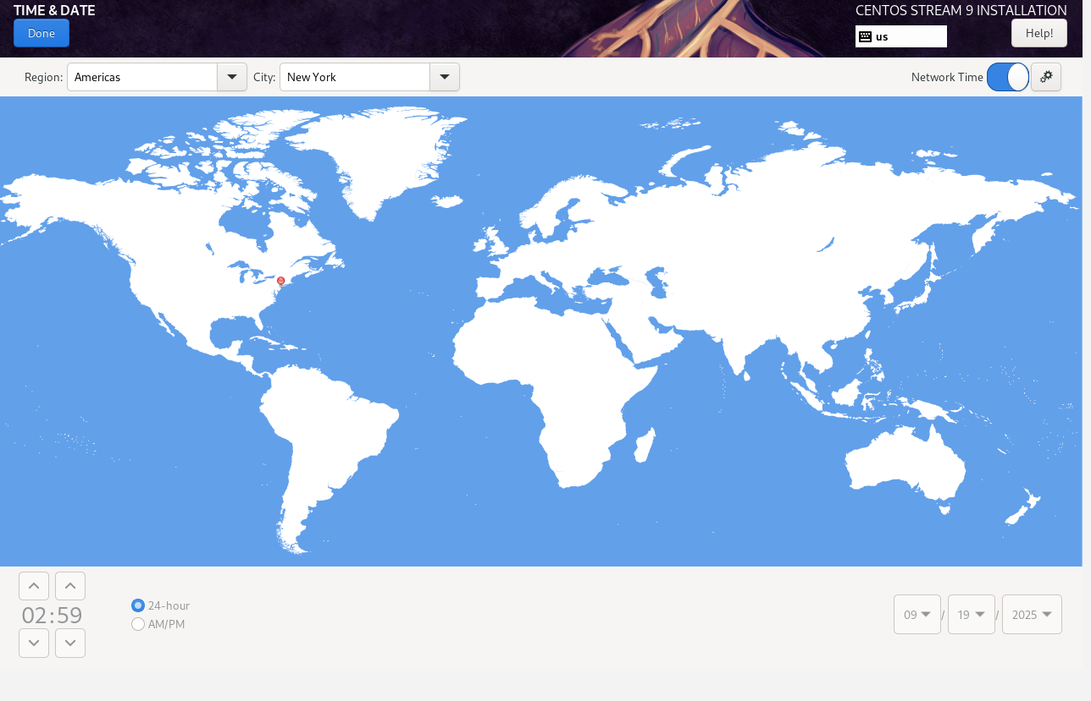

- Select Server Software.
- Under Software Selection, choose Server
- Do not pick GUI or Minimal install
- This gives you the proper server environment (command line only). Think It as the “bare engine” without extra decorations – perfect for learning.
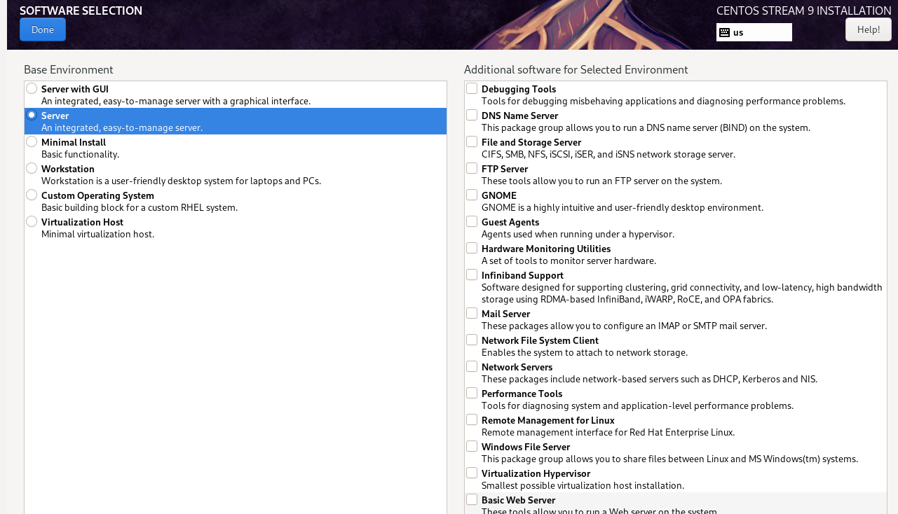

- Choose Installation Disk.
- Go to Installation Destination.
- Select the 20 GB Virtual Disk (VDI) you created in VirtualBox
- Leave partitioning as Automatic so CentOS handles storage setup
- Screenshot proof shows 20 GB dynamically allocated

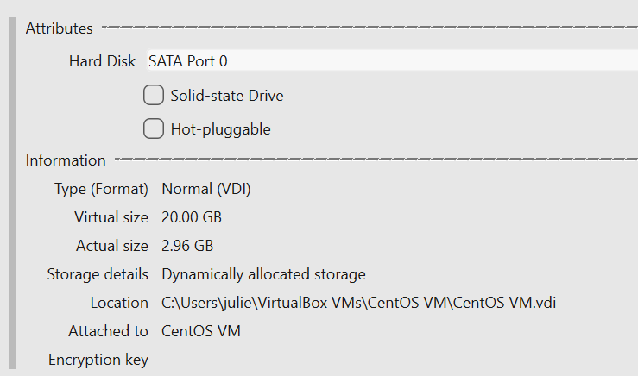

- Set a strong Root Password.
- Enter a strong root password
- Check the box Allow root SSH login with password.
- This allows remote access later using SSH for file sharing between CentOS and Ubuntu server and also let you log in later remotely if needed
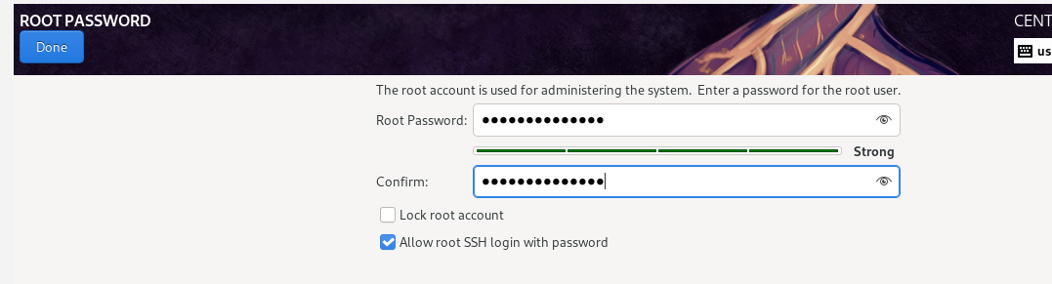

- Create a user name
- Add your name and username
Enter the full name(optional) and choose a username that you will use to log in
Example: juliette
- Next, Check Make this user an administrator.
Check the option “Make this user an administrator” so the account has sudo (administrative” privileges
- Next, set a password and confirm it
Enter a password for this user and confirm it
This password will be required when logging in or running administrative task
- This gives you your own login, like creating a new user account on a laptop

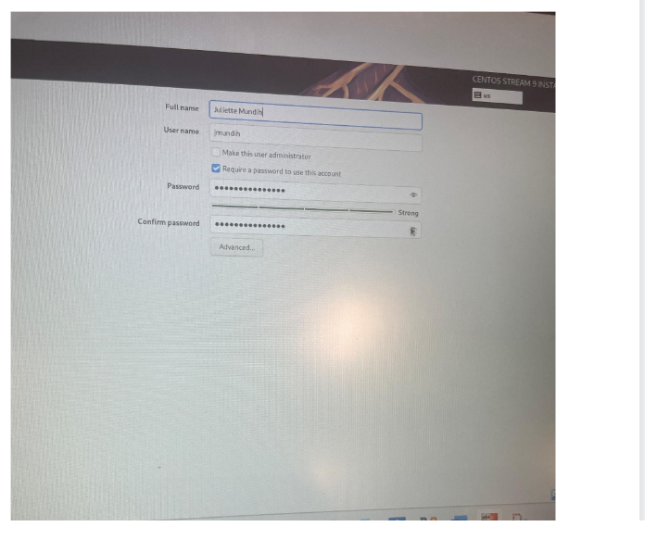
- Begin Installation.
- Review your settings.
- Click Begin Installation
- Wait until it finishes, then click reboot
(this is like the final step to setting up a new phone- you restart and it is ready for use)

- The system will install CentOS on your virtual machine.
- Reboot the system after the installation to begin using the CentOS sever.

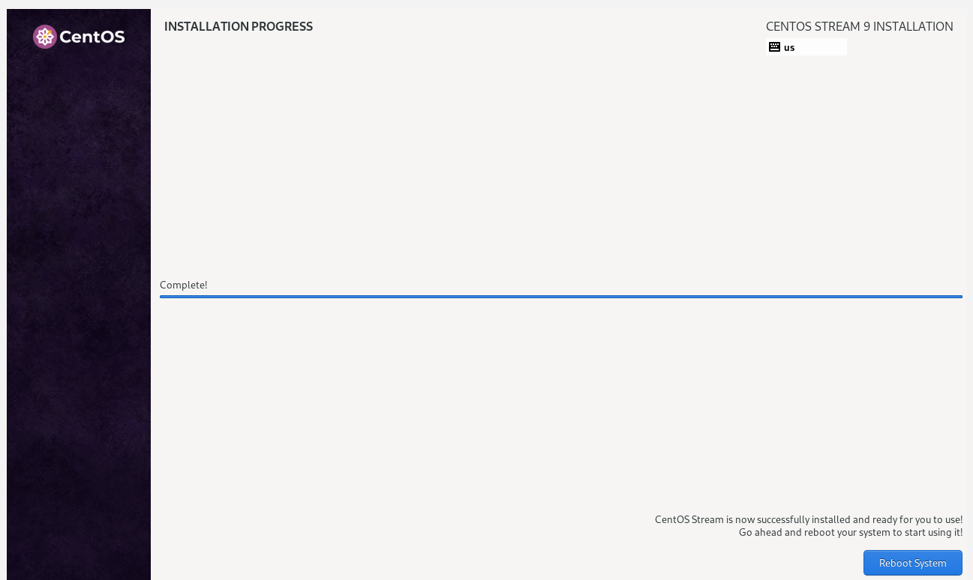

- Next, if the installation is complete, you should be able to see the login screen
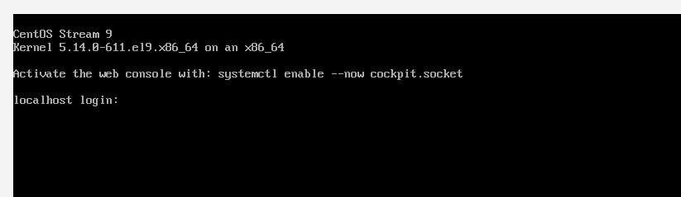

Creating an Ubuntu Server VM.
1.Downlaod Ubuntu Serger ISO
- Open a web browser (Chrome, Edge, or Firefox).
- Go the official site: https://ubuntu.com/downlaods/server .
- Click Download Ubuntu Server 24.04 LTS (64-bits ISO).
- The ISO file will; save into your download folder.
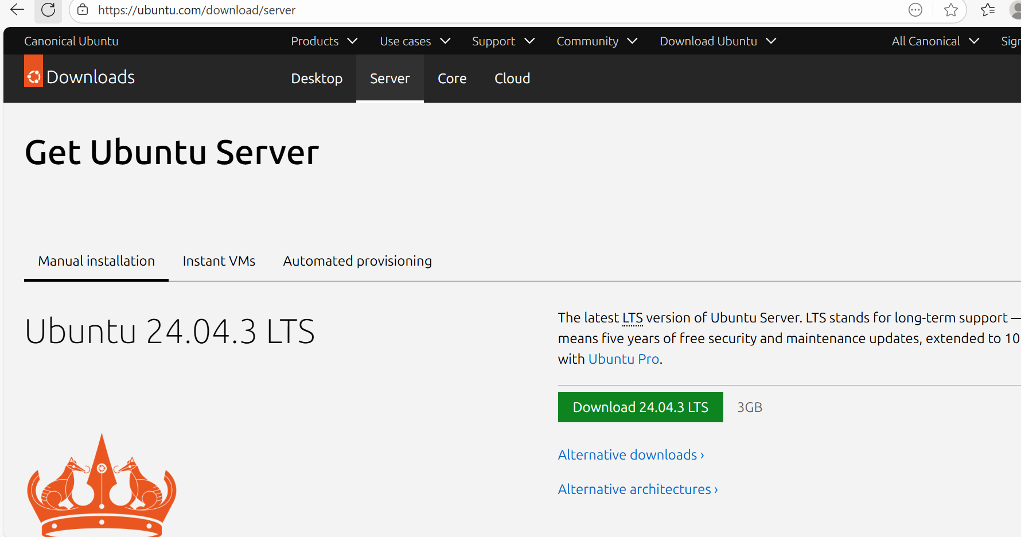

- Create a New Virtual Machine in Virtual Box
- Open Oracle VM Virtual Machine Manager.
- At the top left, click New (the blue star with a sun icon).
- A window will open:
. In Name, type Ubuntu_Server.
. For Type, select Linux.
. For Version, Choose Ubuntu(64-bit)
. Click Next.
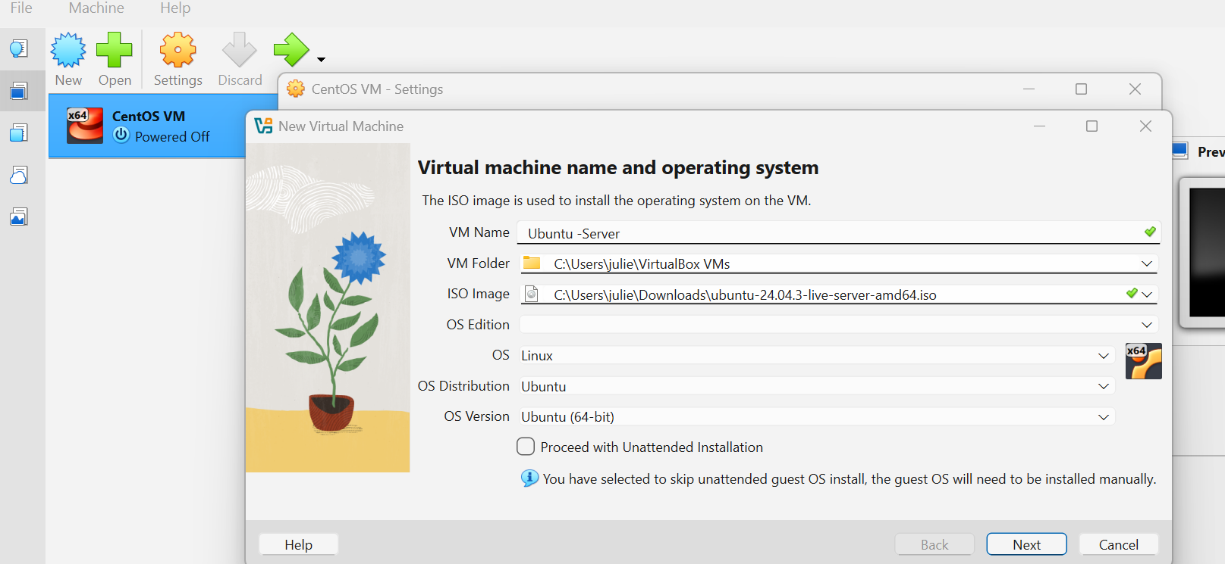

- Virtual Hardware
- Now you will assign memory: move the slider to 4096 MB
- Then you will set the CPU to 2.
- After that, you will create a virtual hard disk to 20 GB (VDI, dynamically allocated)
- Set the number of CPUs to 2
- Click Next.
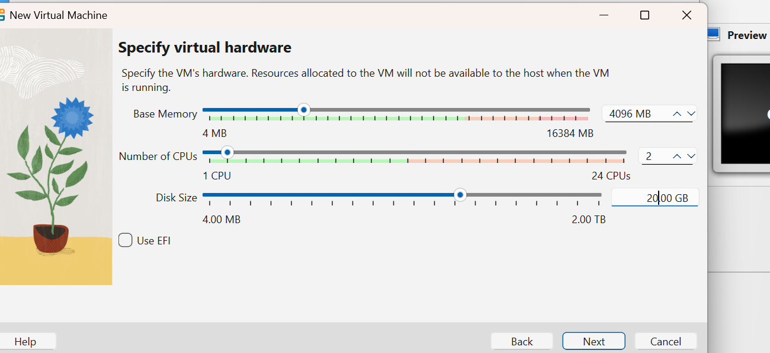
- Attach the Ubuntu ISO.
- Go to the VM setting, In Oracle VirtualBox Manager, select your Ubuntu VM and click settings.
- Click Storage -- On the left panel, choose Storage.
- Attach ISO file - Under Controller: IDE, click the empty disk icon, then browse to your Downloads folder and select the Ubuntu ISO file(ubuntu-24.04.3-live-server-amd64.iso)
- Confirm hard disk- Make sure a .vdi file is listed under controller: SATA (this is your 20GB Virtual hard disk
- Click ok and save
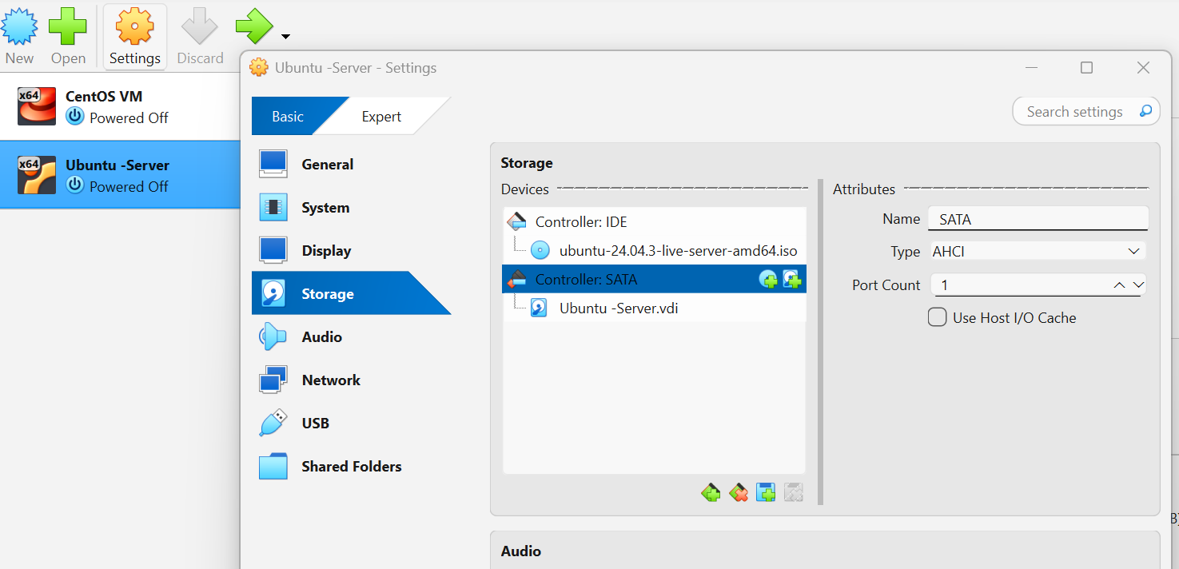
- System check before installation.
- Before clicking on next. Make sure to check the summary of the Ubuntu Virtual Machine configuration
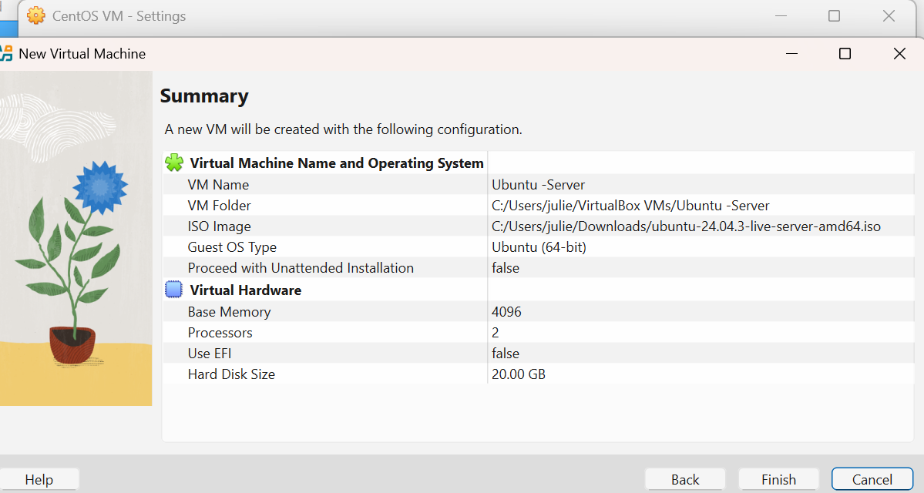

Installing Ubuntu Server.
- Start the Virtual Machine.
- In the Oracle VirtualBox Manager, select your Ubuntu-Sever Virtual Machine.
- Click the green Start arrow.
- The System will boot from the ISO you attached earlier
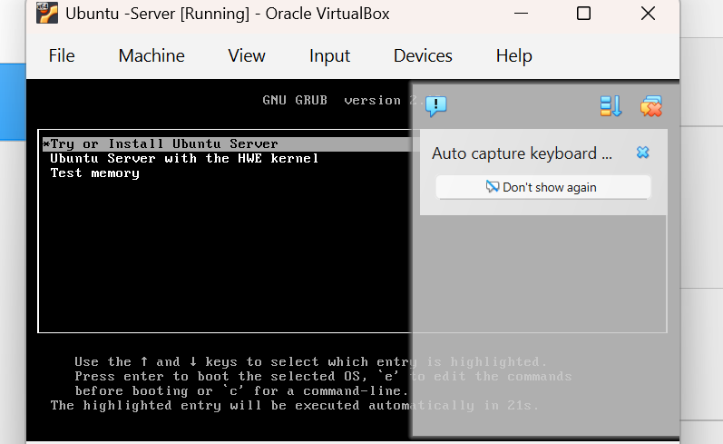
- Select Language.
- On the first screen, use your arrow keys to highlight English (or your preferred language).
- Press Enter.
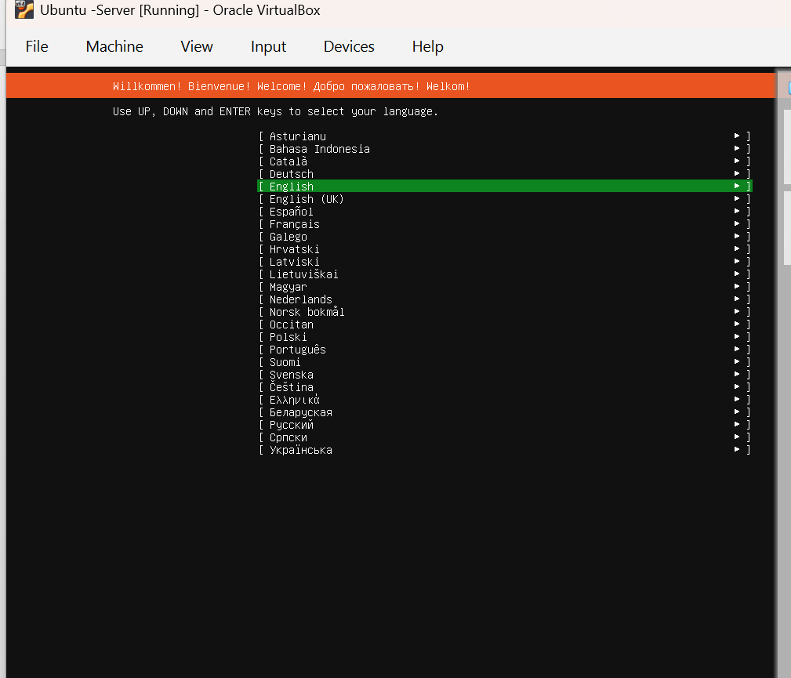
- Select Keyboard Layout.
- Choose English language (US) or whichever layout matches your keyboard.
- Press Enter.
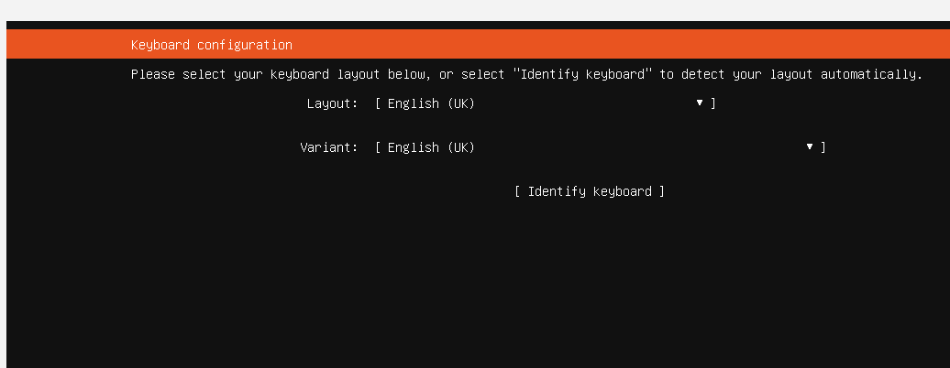

- Select Installation Type.
- Next, you will choose the base for the installation screen.
- Leave the default option Ubuntu Server selected
- Do not choose minimized
- Press Enter on Done and continue.

- Configure Network.
- Next, you will see the Network Configuration screen
- In VirtualBox, open Setting -- Network --- Adapter 1.
- Change the option from NAT to Bridge Adapter on both Servers so the servers can see each other on the same network.
- Leave everything else as default.
- Press Ok and continue with installation.

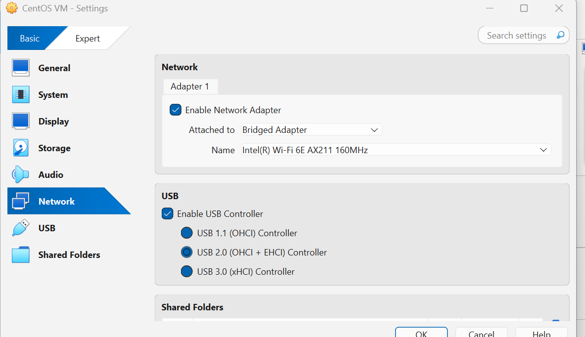

- Storage Configuration.
- Next, you will choose how Ubuntu will use your hard disk.
- Select Use an entire disk to let Ubuntu handle the set up.
- Leave the option Set up as LVM group checked (this makes storage easier to managed).
- Do not select encryption or custom layouts.
- Then click Done and continue
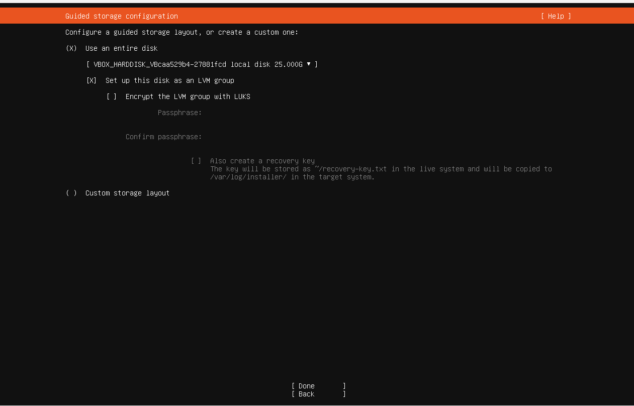
- Storage Summary
- Next, you will see a summary of how Ubuntu will use your disk.
- A small partition is created for /boot (startup files).
- The rest of the space is given to the main system.
- You do not need to change anything here.
- Select Done and confirm the setup
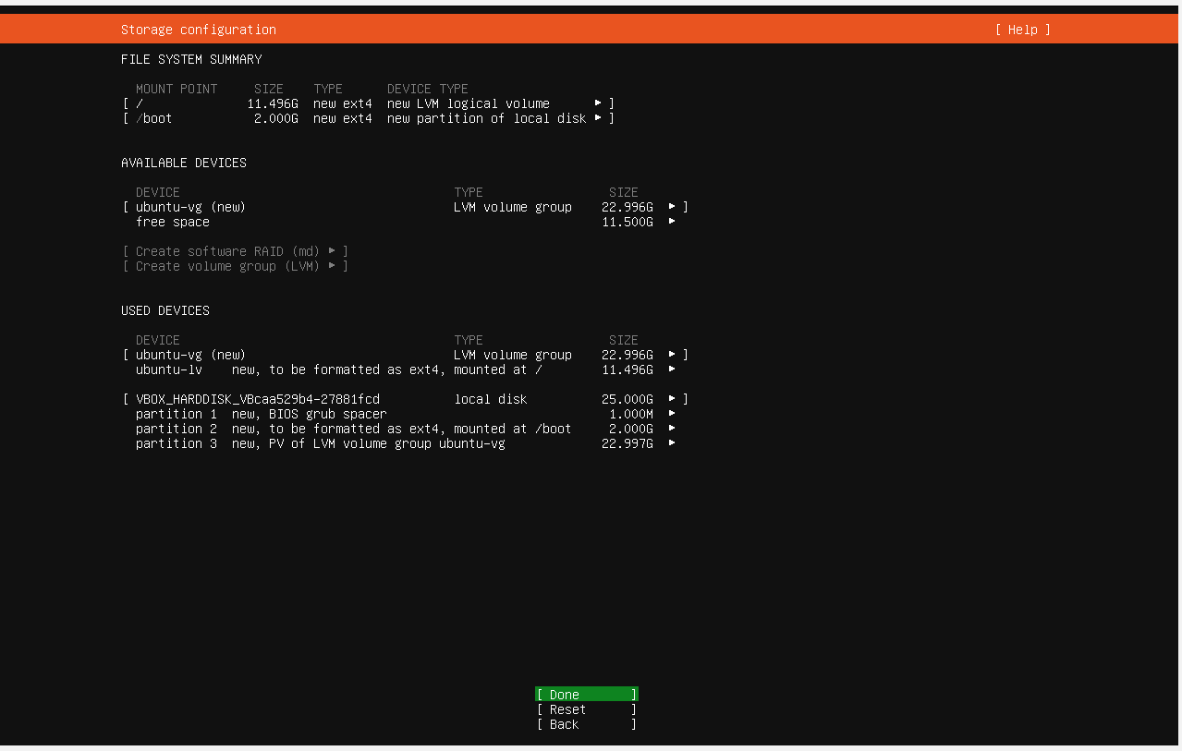
- Profile setup.
- Your name: Type your full name (for example: Juliette Agwe).
- Server’s name: Enter a short, simple name for your server. Example: ubuntu-server. This is the name the system uses when it connects to other computers
- Next, pick a username: Choose a login name that is short, lowercase, and without space. Example; juliette. This is what you will type to login
- Next, choose a password /Confirm your password
Enter a strong password you will remember.
Confirm it by typing it again in the box below.
Make sure it is the same in both boxes.

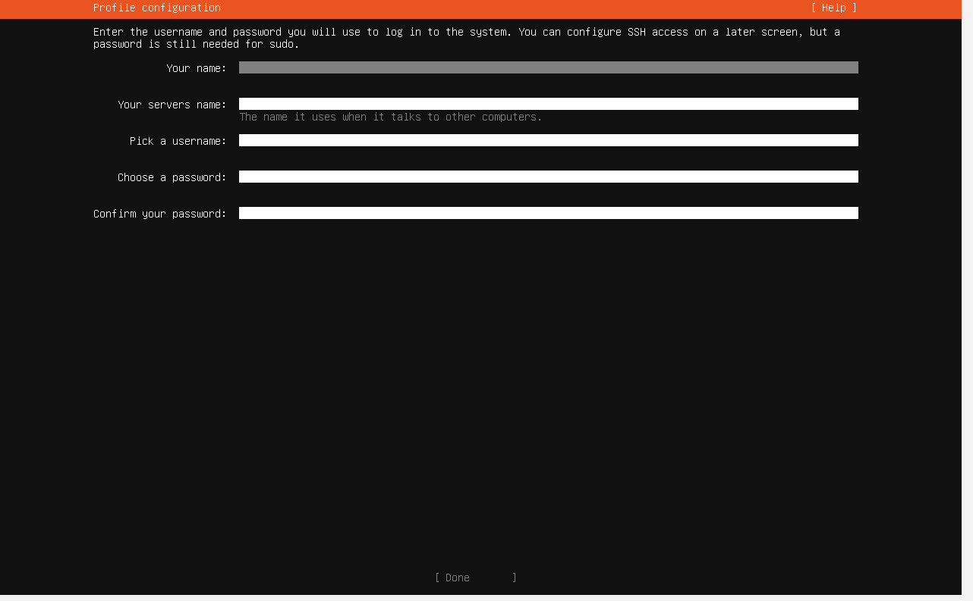
- SSH Configuration Setup.
- Check Install OpenSSH server - lets you connect remotely.
- Check allows password authentication - lets you log in with username and password.
- Leave Authorized Leys blank for now.
- Press Done to continue.
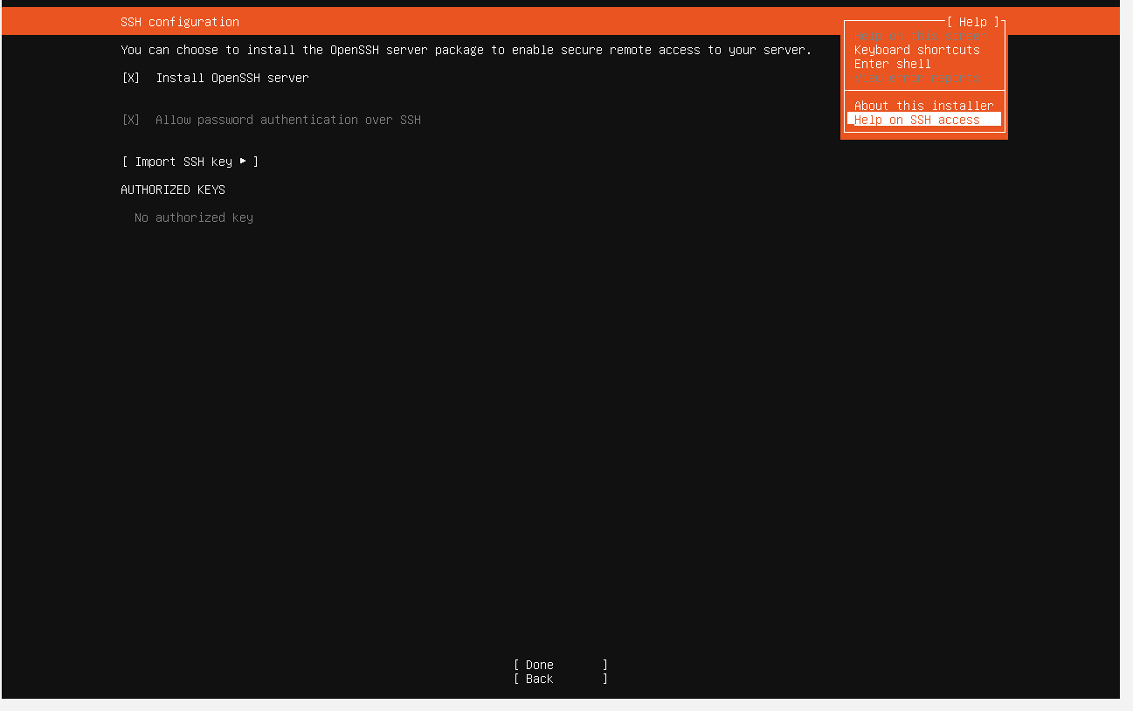
- Installation Process.
- At this stage, Ubuntu begins copying files and installing the operating system. You just need to wait while the setup runs. No input is required here. Allow the installation to complete.
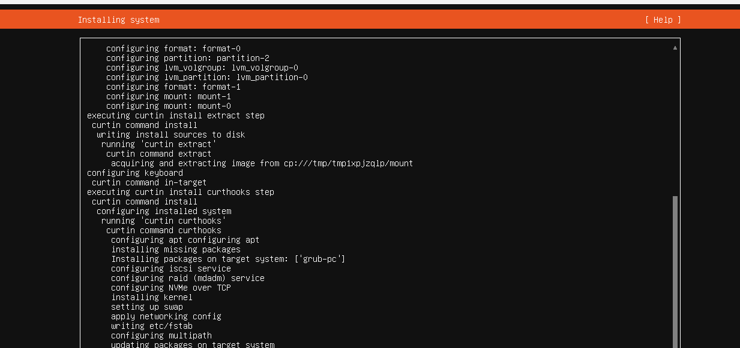
- Finish Installation.
- Once the installation is complete, the system will show the option Reboot Now.
- Select Reboot Now to restart the virtual machine and boot into Ubuntu Server.
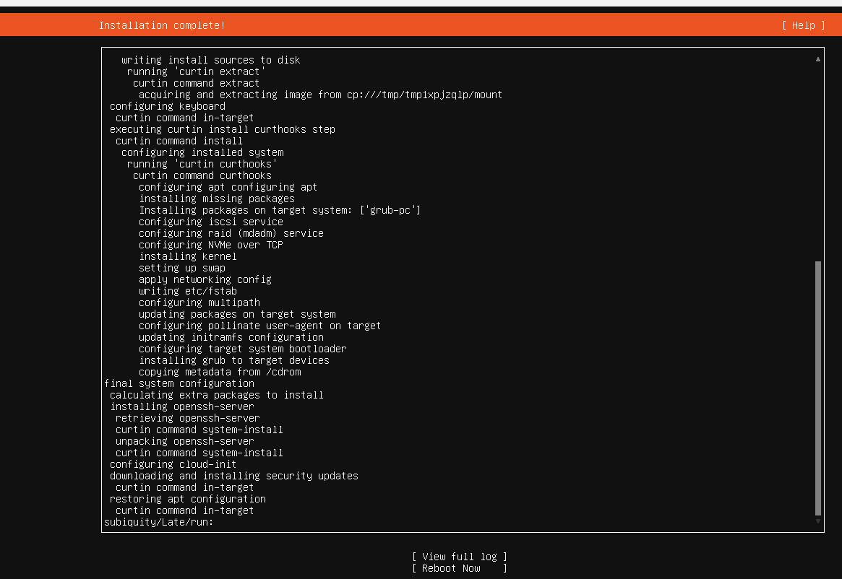

- After the installation, if you see an error about “remove the installation medium,” open VirtualBox Settings- Storage.
- Under Controller: IDE, remove the Ubuntu ISO and leave it as Empty.
- Then click OK and restart the Ubuntu Virtual Machine
- The server will now boot from the installed hard drive instead of the CD.
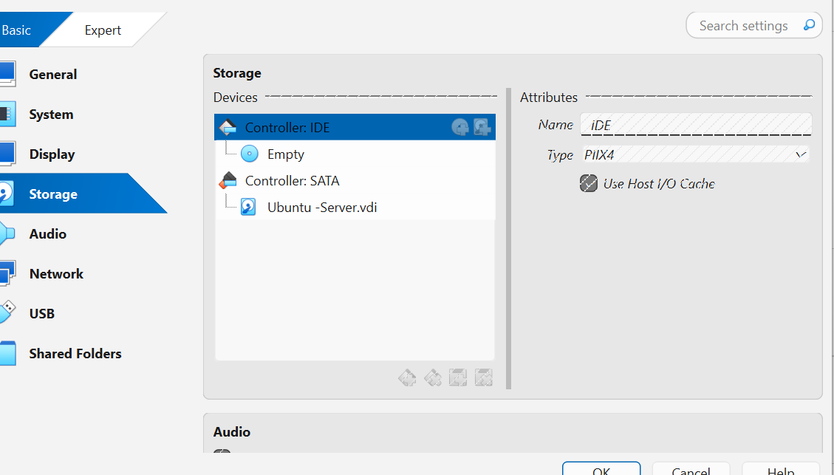
- After a successful reboot, you should be able to login with the username and password you created earlier.
- 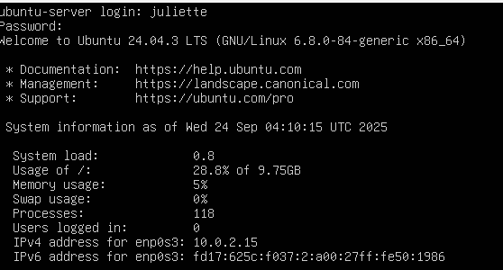
- Check IP address
- On each server, type ip addr to display the network interface and assigned Ip address. This confirms each server has a valid IP address for networking.
- Look for the inet line under your main adaptor (usually enp0s3)
- This line shows the server’s assigned IP Address.
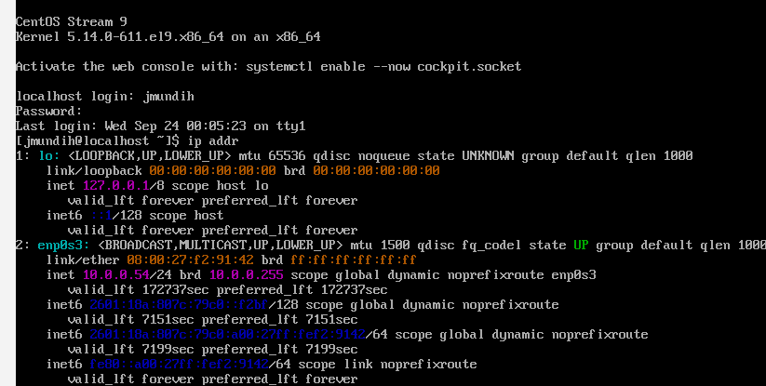

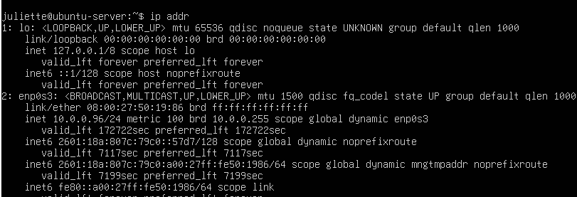

- Test Internet on Ubuntu.
- On Ubuntu, type ping -c 4 www.google.com
- Next, if you see replies like:
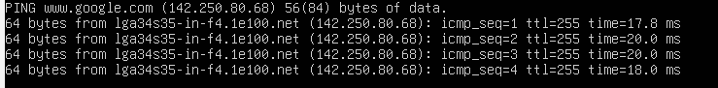
--- This means Ubuntu has internet access.
- On CentOS.
- On CentOS server. Type ping -c 4 www.google.com
- Next, if you see replies like this:

--- That means CentOS has internet connect
- Test Connectivity Between the Two Servers.
- Next, you will check if the two serves can talk to each other.
- Login into the first server (CentOS), Type this command to ping <Ubuntu IP>
Do same with same with Ubuntu Server. Type this command:
Ping <CentOS IP>
- If the servers can reach each other, you will see “bytes from….” Messages and 0% package loss in the statistics.
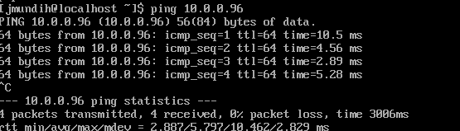
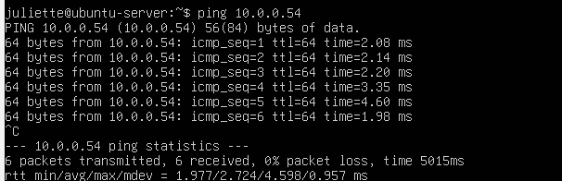

- File Sharing Between Ubuntu and CentOS
Before, you can be able to share files between your newly created servers, you must do the following:
- Setup SSH for File Sharing
On Ubuntu, type: sudo apt install openssh-server -y in the command line. Remember to include your password if you want this command to work. Reason being that the sudo command is an administrative command that requires the use of the account password
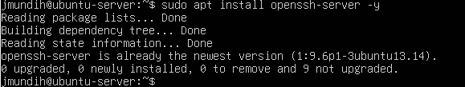

- Enable SSH service to start automatically on boot by typing:
Sudo systemctl enable ssh.
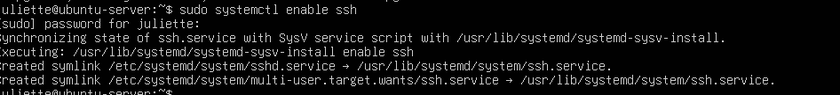
- Next, Start the SSH on the Ubuntu server by typing: sudo systemctl start ssh and sudo systemctl status ssh
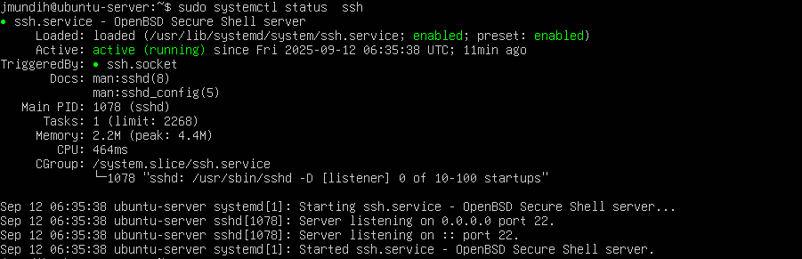

- Enable SSH Service on CentOS.
- Install OpenSSH Sever by typing sudo yum install openssh-server -y.
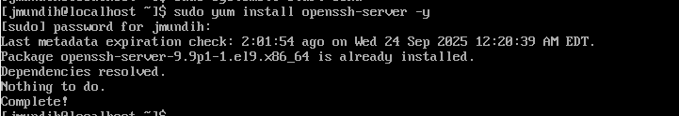

- Enable SSH service on CentOS to start automatically on boot by typing: sudo systemctl enable sshd and confirm if the sshd service is up and running by typing: systemctl status sshd.
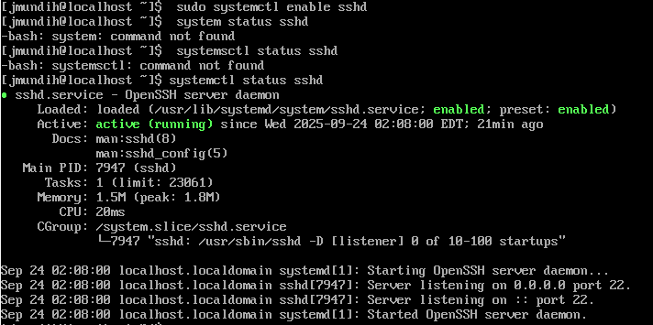.
- After SSH and SSHD is enabled on both servers, you can now share files using scp by doing the following:
- Create a test file on Ubuntu.
On your Ubuntu Server, make a file to send to CentOS server by using the echo command. This command creates a file named ubuntu.txt with some text inside.

- After you create this file, now copy the file from Ubuntu to Centos using the scp command: scp, filename, Centos Username, CentOS server Ip and the destination folder. See screenshot below.
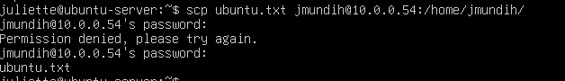

When asked, type the CentOS password. If correct the file will be successfully transferred over the CentOS server.

- On CentOS (check if the file was successfully transferred over by using the ls /home/ jmundih command. Remember jmundih in this case is the destination folder where the file will be. If the file transfer was a success, you should see ubuntu.txt in your CentOS server home folder.
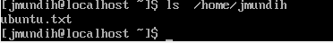
- File Sharing from CentOS to Ubuntu
- Create a test file on CentOS Server.
On your CentOS Server, make a file to send to Ubuntu Server by using the echo command. This command creates a file named centos.txt with some text inside.
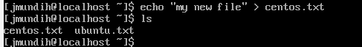
- After you create this file, now copy the file from CentOS to Ubuntu using the scp command: scp, filename, Centos Username, Ubuntu server Ip and the destination folder. See screenshot below.
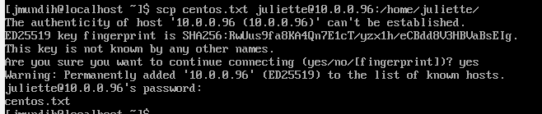
- First-time connection - types yes when asked about authenticity
- Enter your Ubuntu Server password when asked

- On the Ubuntu Server (check if the file was successfully transferred over by using the ls /home/ juliette command. Remember juliette in this case is the destination folder where the file will be. If the file transfer was a success, you should see centos.txt in your Ubuntu server home folder.
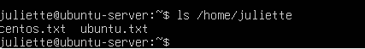

Conclusion.
I have been able to show step by step how a Virtual Machine is downloaded, Installed with two servers on in. Also, I have shown steps to download and install these servers with prove of internet connection between these servers and the ability to share files among these servers.

